https://www.wolframalpha.com/
https://36kr.com/p/11500?utm_source=site_search
https://reference.wolfram.com/language/guide/CreatingAnInstantAPI.html

https://www.infoq.cn/article/2009/10/Wolfram-Alpha-API
在 Wolfram Research注册后得到的 APPID
https://products.wolframalpha.com/api/
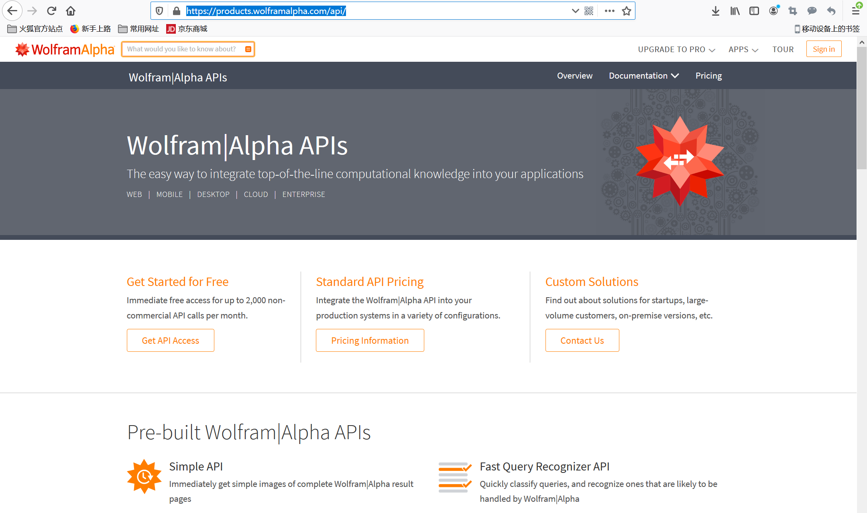
Click “Get API Access” to get started for free.
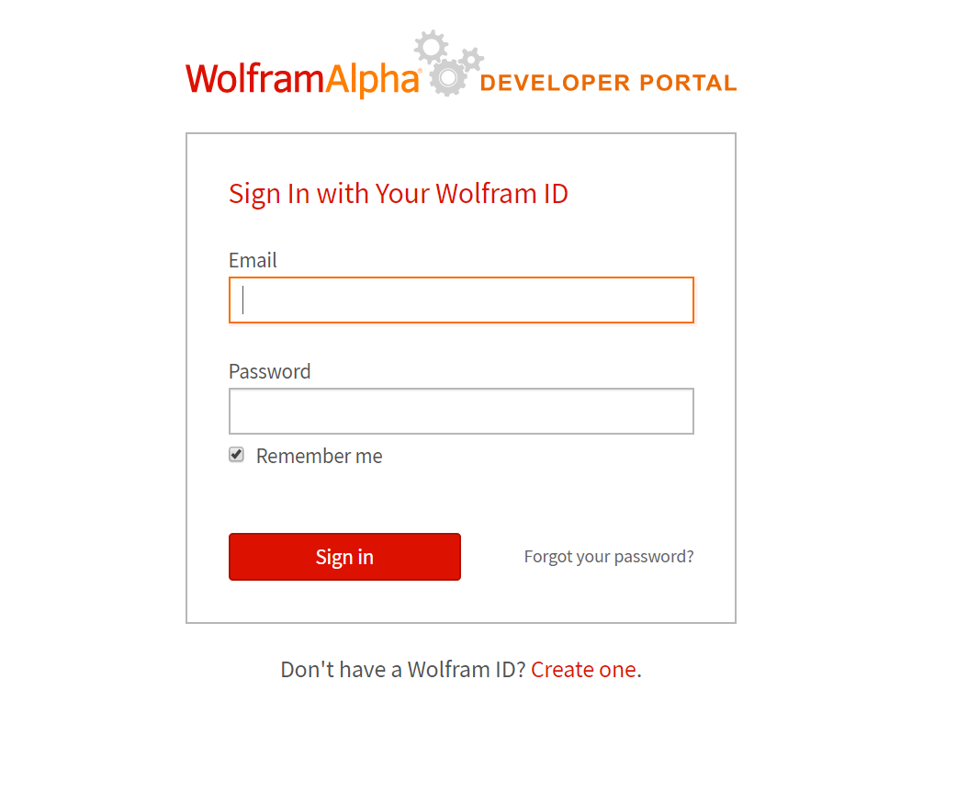
Click “Create one”, fill in information.
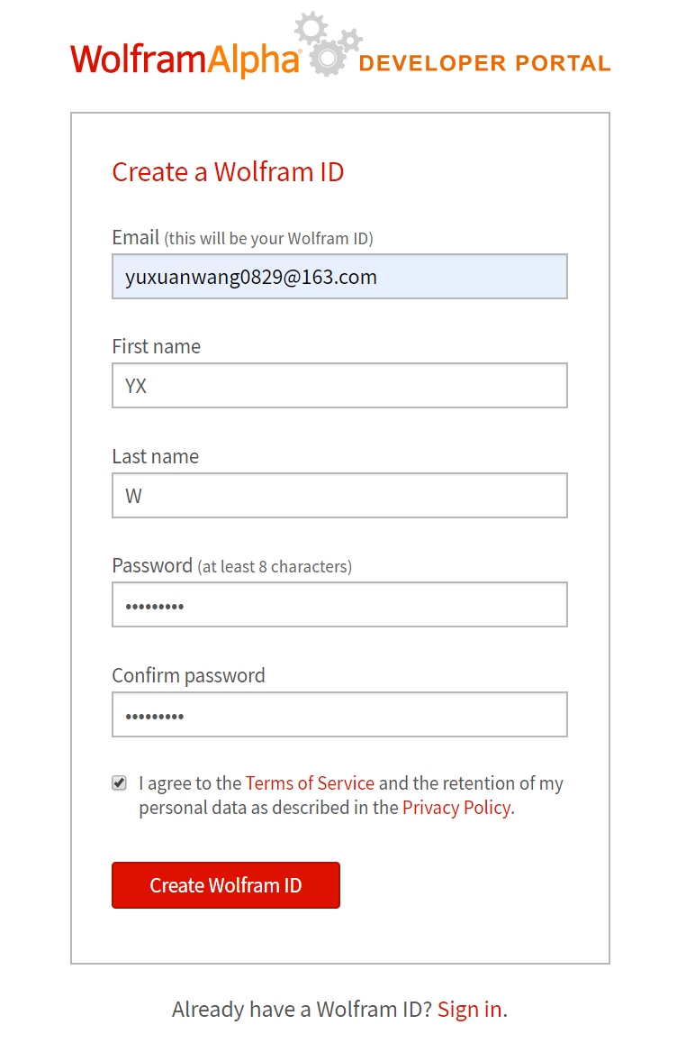
Click “Create Wolfram ID” to create a ID.
Verify the ID through your email. Then sign in.
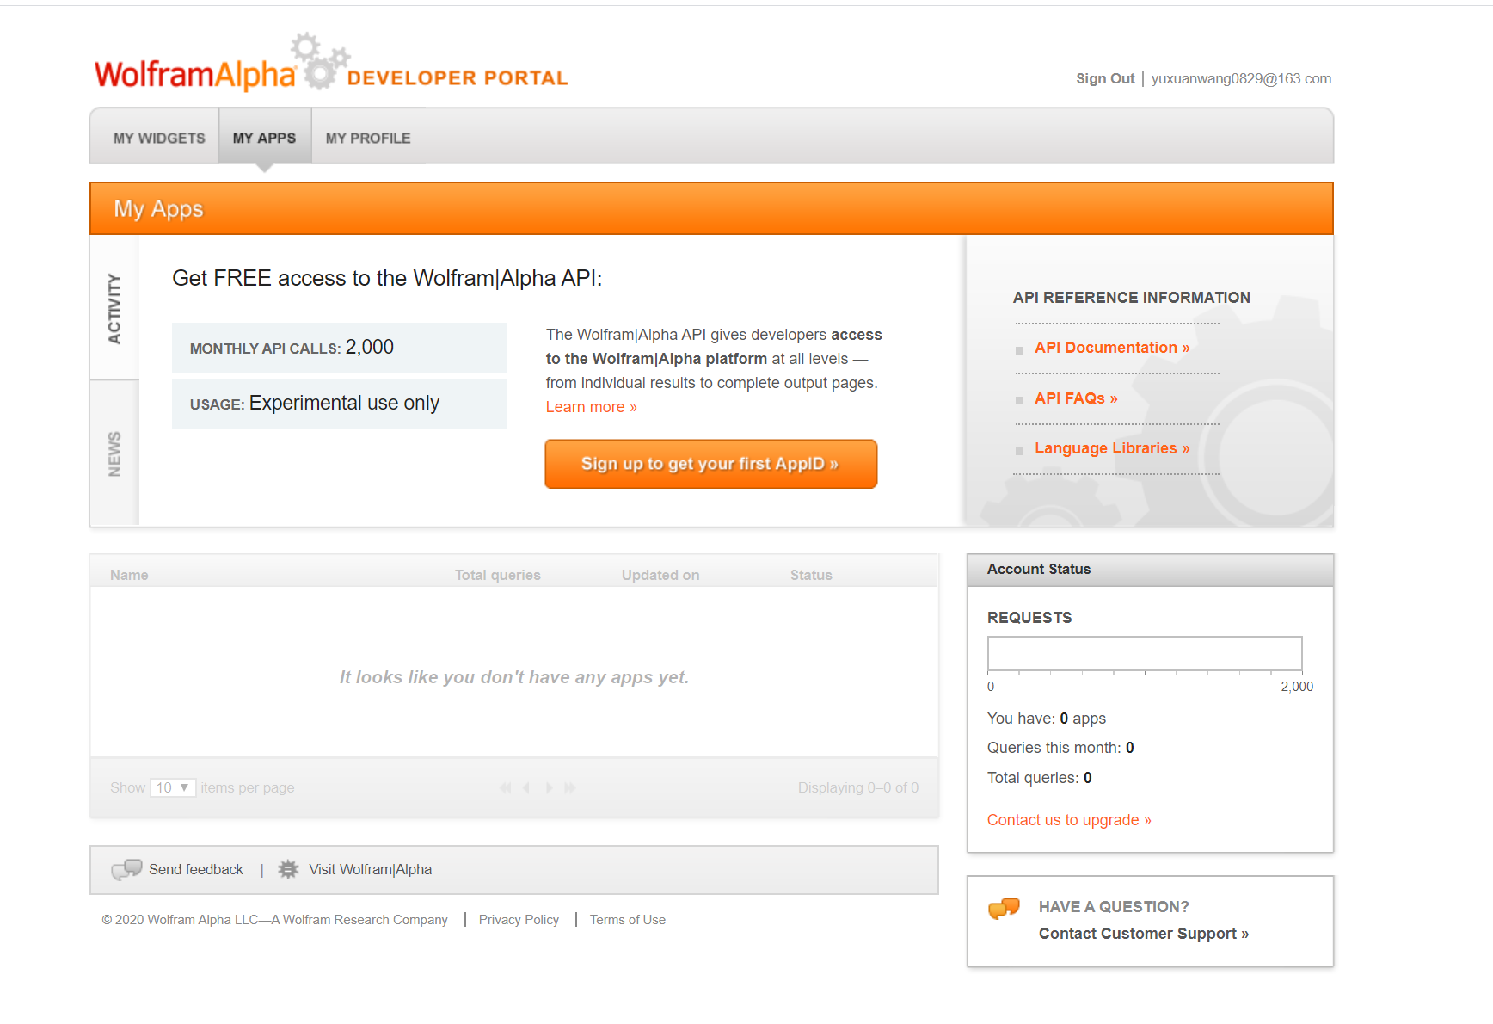
Click “Sign up to get your first AppID”
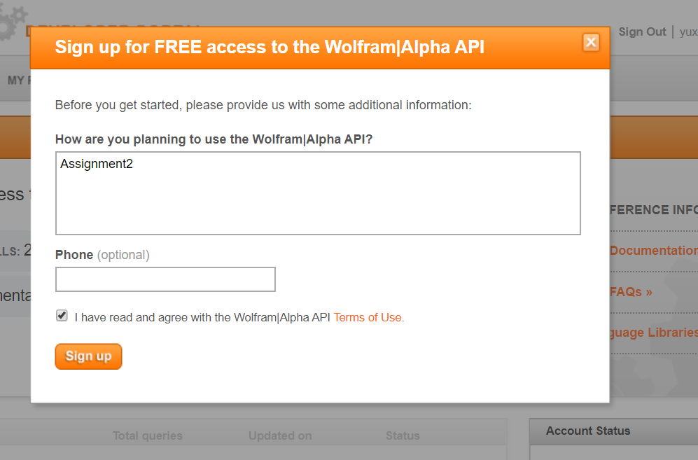
Click ”Sign up”

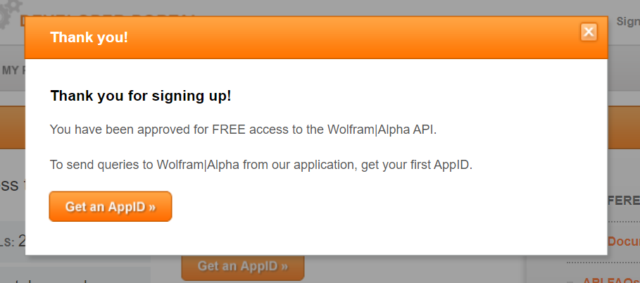
Click “Get an AppID>>”
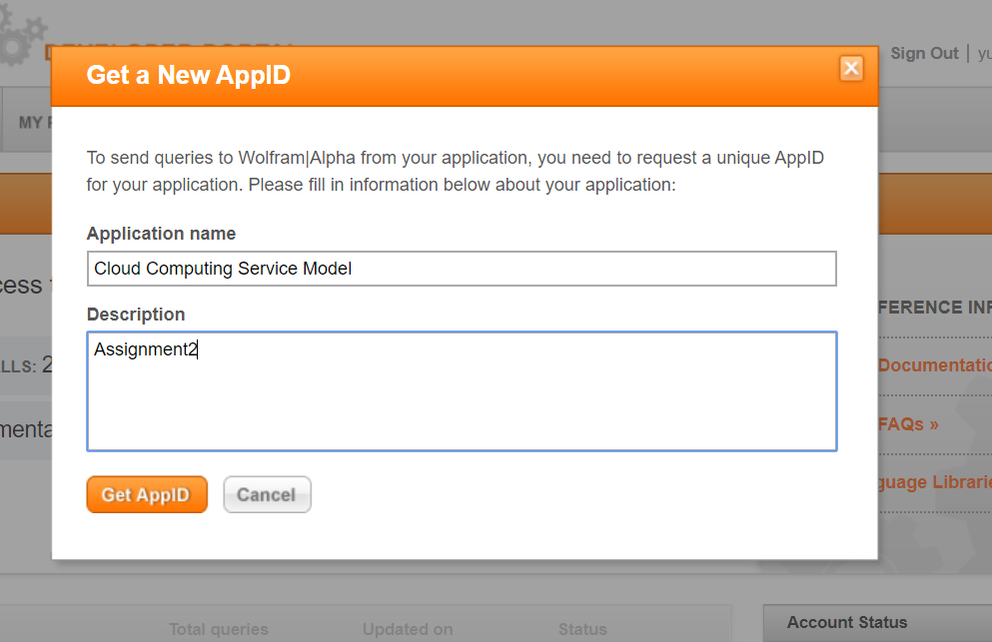
Click “Get an AppID”
